Freedom Crossing Academy
P.E. Uniform Pre-Orders

6th- 8th Grade students will dress out weekly for a grade in their P.E courses

Individual gym lockers will be distributed to students. Students will be required to bring in a combination lock.

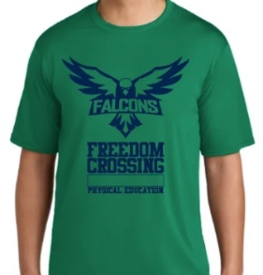
$15.00 per Performance Tee
Youth S - Adult XL

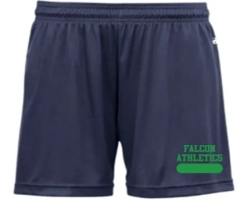
$20.00 per Girl’s Performance Short
Youth S* - Adult XL**
*All youth sizes are unisex

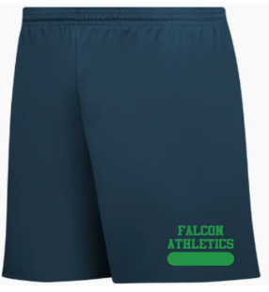
$15.00 per Boy’s Performance Short
Youth S* - Adult XL**
*All youth sizes are unisex

All uniforms can be purchased by sending
Cash or check in with your student to their
PE Teacher. Please send exact amounts because
we are unable to make change. Sizes are limited
so we will do our best to accommodate the sizes needed.

