Freedom Crossing Academy
TV Productions Elective Application
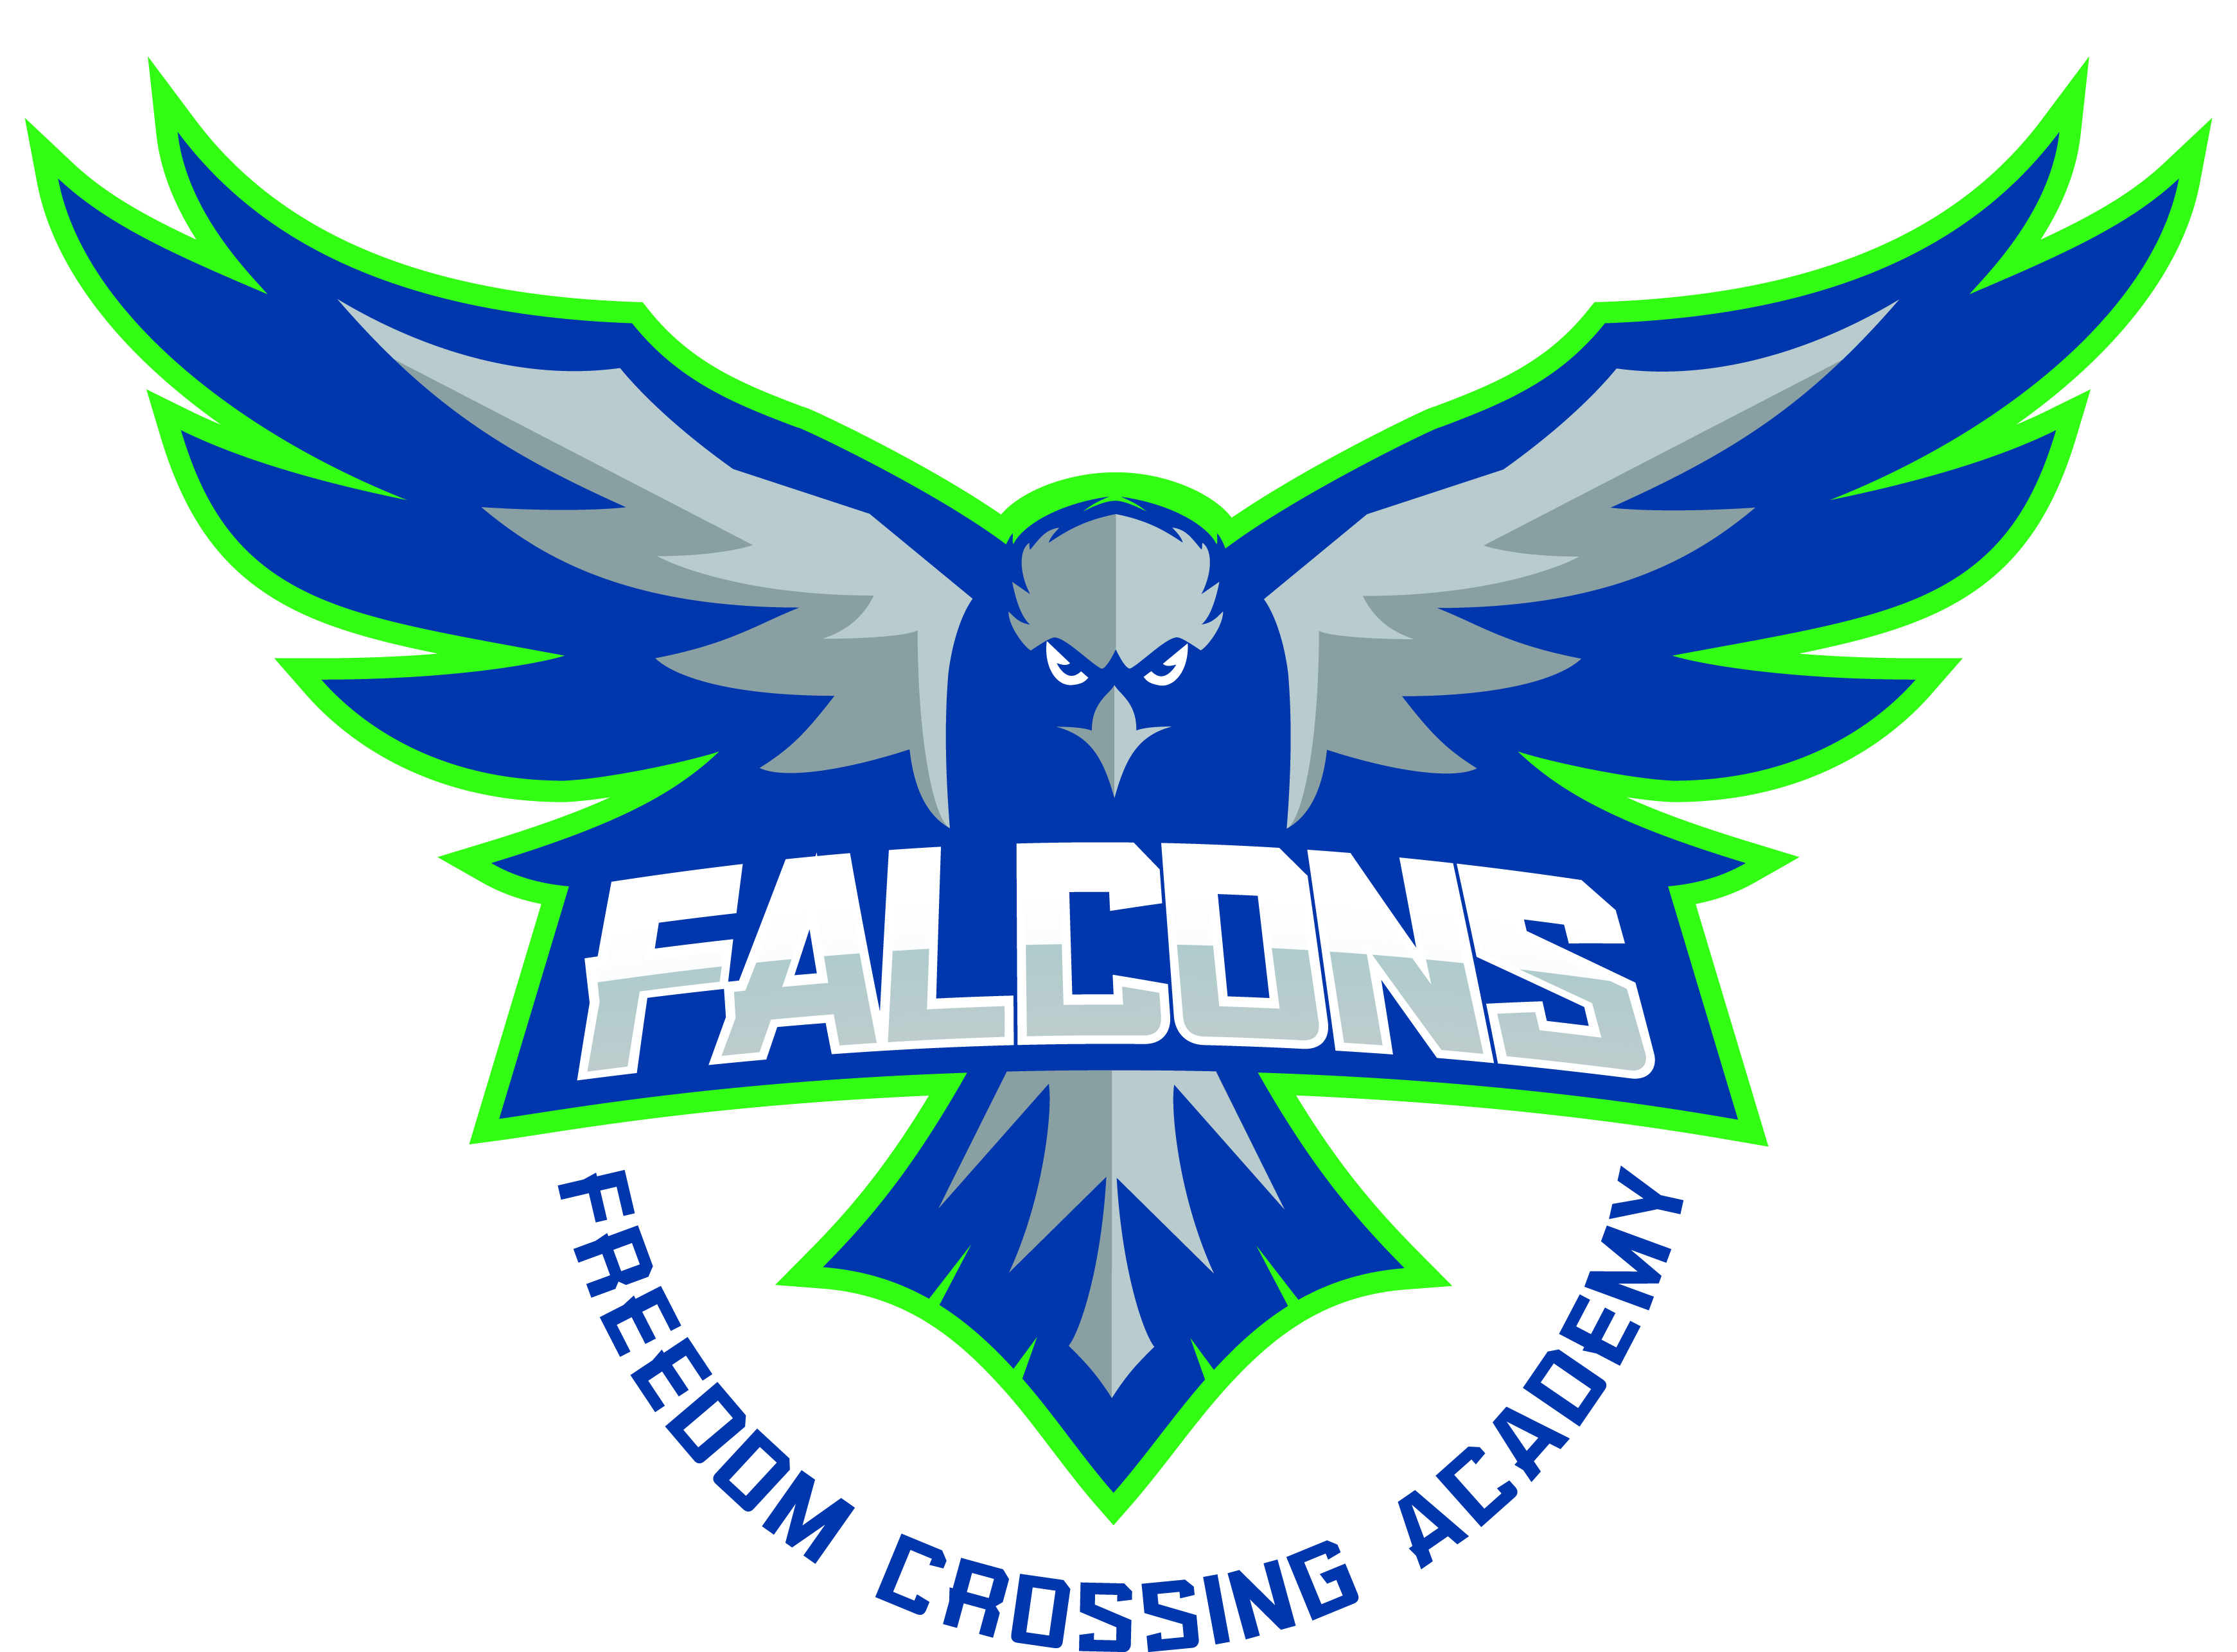
Hello FCA Falcons! Thank you for your interest in being a part of our TV Productions Elective Class! Several students have expressed an interest in being a part of this class. Due to class size limitations, some students will end up taking their 2nd or 3rd choice elective class. In order to select which students are best suited for the TV Productions elective, we ask that you complete the application attached.

There are FOUR components to this application:
- An essay that describes why you want to be a member of the class
- An original news script
- A list of ideas for video projects
- A Teacher Recommendation form (to be filled out by a current teacher)

You may handwrite your responses if you choose, but your handwriting must be clear and legible. If you prefer to type your responses, a digital copy of this application is available on the FCA Media Center website.

All applications must be turned in no later than Friday, May 17, 2019.

If you have any questions, please see Mr. Ostrowsky in the Media Center or contact him at matt.ostrowsky@stjohns.k12.fl.us.

FCA TV Productions Elective Application:
Persuasive Essay

First and Last Name: _______________________________________

Directions: Please explain why you are interested in being a part of the TV Productions Class at Freedom Crossing Academy. Also explain why you think you should be selected to be a member of the class. What makes you stand out from others? What qualities do you have that you would bring to the class?

FCA TV Productions Class Application:
Original Script

First and Last Name: _______________________________________

Directions: Please compose your own original news script. You must include the following:
- A creative opening/greeting line.
- Three (3) REAL news stories, written in your own words. You may use local/national current events, results of recent/ongoing sporting events, human interest pieces, or any other recent non-controversial stories you have seen or read in the news recently.
- Logical, smooth transitions from one news story to the next.
- A creative closing “tagline.”

To help you compose your own news script, watch some local and national news programs to gather ideas!

FCA TV Productions Class Application:
Video Ideas Report
First and Last Name: _______________________________________

The FCA Morning News show will be just one component of our TV Productions class. Throughout the year, we will also be working on creating other video projects including (but not limited to) a virtual tour of the FCA campus, Public Service Videos, book trailers, and more.
For each category below, please provide an original idea for a video you would like to make. (For example, what is a topic for which you would like to create a documentary or instructional video? What important social issues merit a Public Service Announcement?

Video Category | My Ideas
Book Trailer
A video advertisement for a book, which employs techniques similar to those of movie trailers. (Provide the titles of a few favorite books for which you would like to create a trailer.)
Documentary
An original program that documents real facts by providing a view of real events and people.

Instructional Video
A program that helps people learn something by giving step-by-step instructions.

Public Service Announcement
Includes short messages, which inform the public or changes public opinion, actions, or feelings.

FCA TV Productions Class Application:
Teacher Recommendation Form

Applicant’s Full Name: __________________________________________

Teacher Completing Form: _________________________________________

The student listed above has expressed an interest in taking TV Productions as an elective course for next school year. We would appreciate your input on whether he/she is a good candidate for the program. Please take a moment to rate this student in the following categories, with 5 being the highest rating and 1 being the lowest rating.

 | 5 | 4 | 3 | 2 | 1
Creativity
Initiative
Motivation
Respect for Others
Self-Confidence
Social Maturity
Academic Achievement
Critical Thinking Skills
Intellectual Curiosity
Leadership
Written Expression
Oral Expression

Please rank this student’s likelihood of succeeding in this program. (Circle one)

Very Likely Likely Somewhat Likely Not Likely

Please add any comments below or on the back that would help us determine whether this student would be a good candidate for the FCA TV Productions program. Thank you in advance!

Teachers—please submit this recommendation directly
to Mr. O’s mailbox no later than Friday, May 17, 2019.

