Families,
Freedom Crossing Academy (FCA) now has a mascot!!!! We had a wonderful turnout from our survey. One mascot was an overwhelming favorite. After we adjusted the responses to take out the multiple responses from the same IP address the results were the same. We will be known as the Freedom Crossing ‘Falcons’. Falcons are known for their great vision and we will use this to encourage our students to look to their future as they attend FCA. We had designers from around the world working on possible logo designs. In the end the best one came from Leonard’s Studios, right here in St. Augustine. I am sure we will use many variations of this, but this will be a good start.
REMINDER: I would like to invite all our families of rising Freedom Crossing Academy 6th graders to a meeting (tonight) Tuesday, April 17th. We will begin at 6:30pm in the Creekside H.S. Auditorium. I see that one of the scheduled reminders did not go out. I want to be sure that all our families of these students are able to attend. Therefore, I will scheduling another presentation to take place in the coming weeks.
Extended Day – We are working on the final contract, but I am happy to announce that we will be working with Village Academy to provide Extended Day services in the coming year. They have a website where you can find more information. We expect everything to be finalized in the coming weeks at which time we will forward registration information.
Our PTO met recently and has done a lot of work already. I am so impressed by the organization and the vision they have. We will have a section on the website soon with contact information for them.
We know there are a lot of things that you may be getting from other school for the coming year, supply lists, course requests, etc. Please know we are aware of these things and will get them to you in plenty of time for your child to be prepared for next year. We are still in the process of building a staff and hiring teachers, so there are still a few uncertain things that we would like to have more information about before we make requests of you. We are trying to avoid as many mistakes (we will make some) and causing any confusion or wasting any resources. Thank you for your patience and understanding.
Future plans include a day where our families can come together to meet each other in a fun relaxed environment. Also, if time allows, we hope to provide some school tours prior to the opening.
The school is coming along nicely and I am looking forward to showing it to all of you.
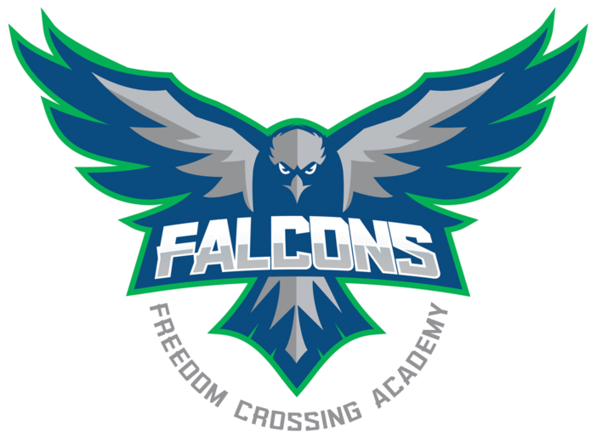
Allen Anderson
Freedom Crossing Academy

